LAB ASSIGNMENT-3.1
V. RACHANA
2303A52335
Task 1:Zero-Shot Prompting (Palindrome Number Program):
Prompt: Write a Python function that checks whether a given integer number is a palindrome.
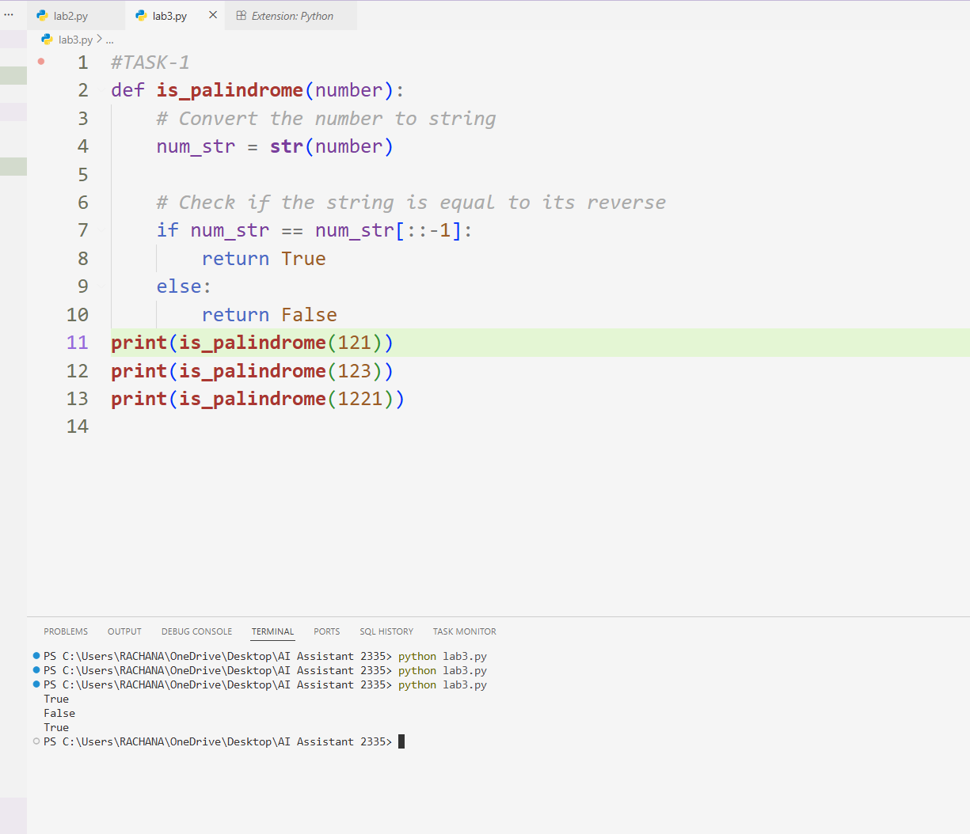
The program works by converting the given integer into a string and then comparing it with its reversed version. If the original and reversed strings are the same, the number is identified as a palindrome; otherwise, it is not. This method is simple and efficient, as string reversal in Python is straightforward. The approach works well for positive integers of any length, while negative numbers are not considered palindromes because the minus sign affects the comparison.
Task 2: One-Shot Prompting (Factorial Calculation) Prompt: Write a Python function to calculate the factorial of a given number
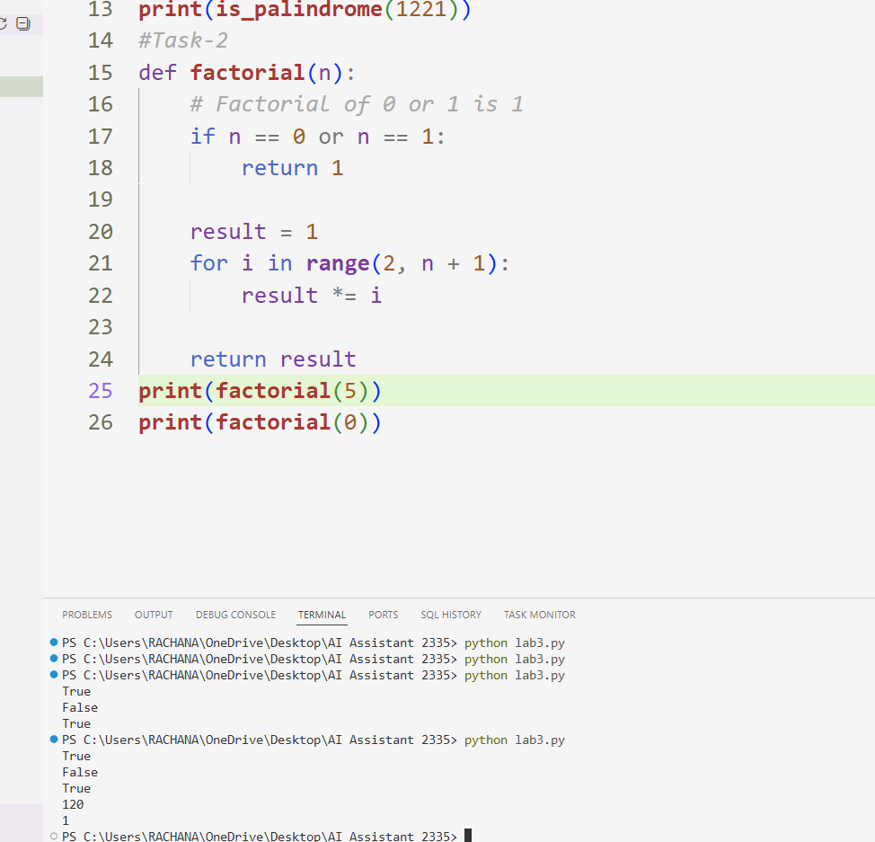
The factorial function calculates the result by multiplying all positive integers from 1 up to the given number. It correctly handles special cases such as 0 and 1 by returning 1 immediately. The use of a loop makes the logic easy to understand and avoids recursion-related overhead. This approach works efficiently for small and moderate values of the input number.
Task 3: Few-Shot Prompting (Armstrong Number Check)
Prompt: Write a Python function that checks whether a given number is an Armstrong number and prints the appropriate result.
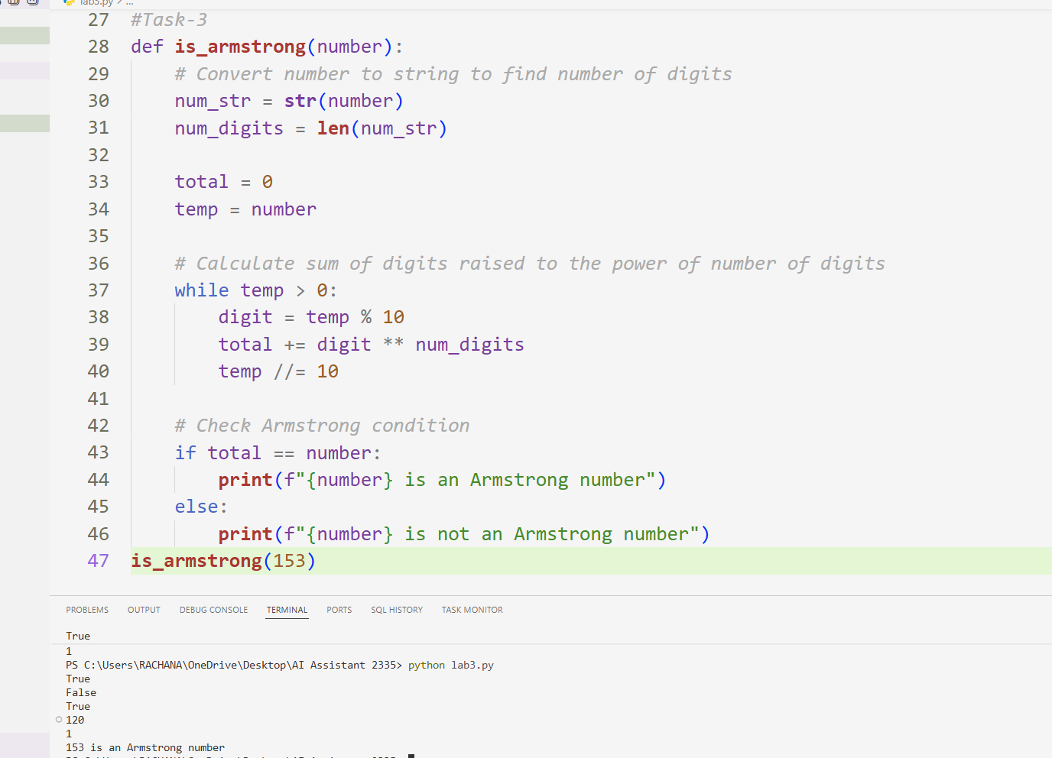
Observation
The function determines whether a number is an Armstrong number by calculating the sum of each digit raised to the power of the total number of digits. By comparing this calculated sum with the original number, it accurately classifies the input. Using examples such as 153 and 370 helps demonstrate correct behavior, making the logic easy to understand and verify.
TASK 4; Context-Managed Prompting (Optimized Number Classification) Prompt:Write an optimized Python function that accepts an integer or numeric string as input, validates it, and classifies the number as Prime.
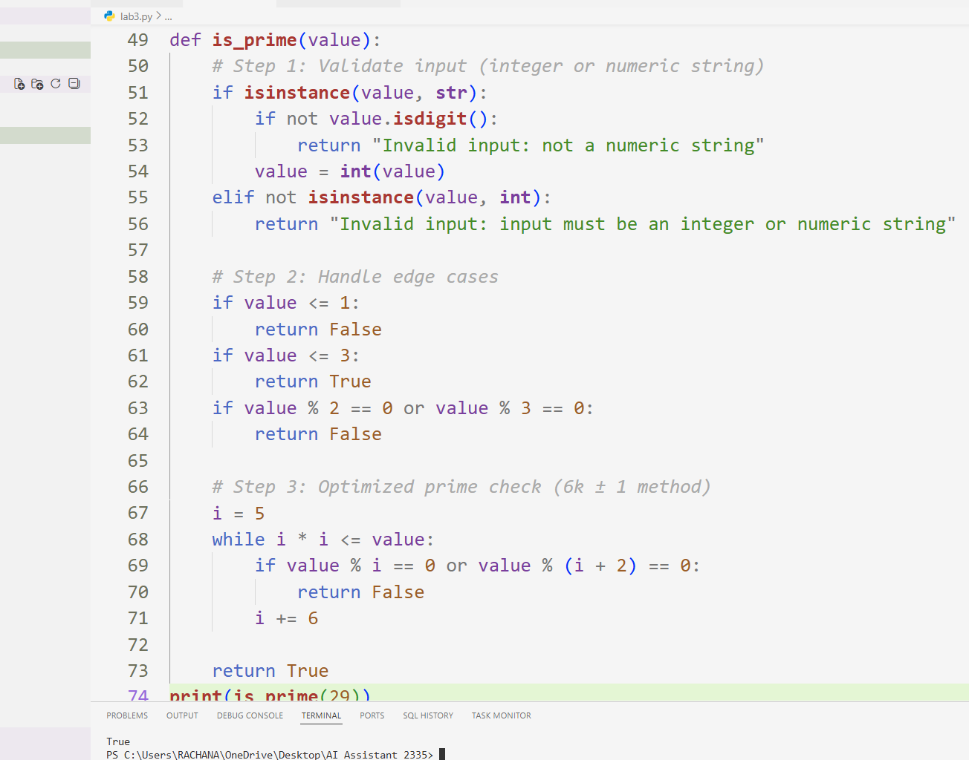
Observation
The function first validates whether the input is an integer or a numeric string, ensuring robustness against invalid data. After handling edge cases such as numbers less than or equal to 1, it applies an optimized prime-checking technique that reduces unnecessary iterations by checking divisibility only up to the square root of the number. Using the 6k ± 1 approach significantly improves performance for larger numbers while maintaining accuracy.
TASK 5; Zero-Shot Prompting (Perfect Number Check) Prompt: Write a Python function that checks whether a given integer is a perfect number and returns an appropriate result.
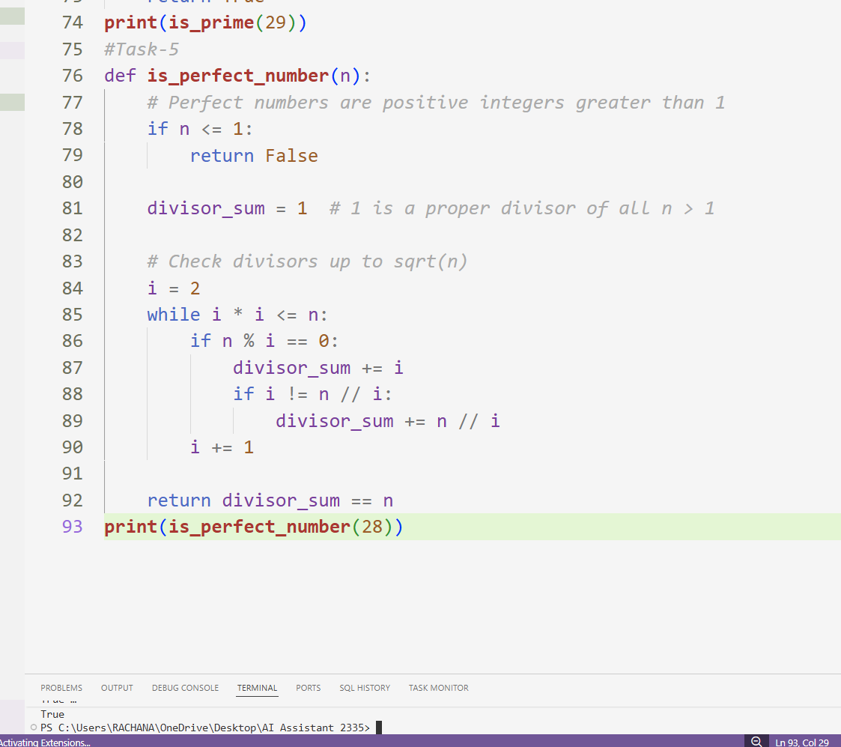
Observation
The function checks whether a number is perfect by calculating the sum of its proper divisors and comparing it with the original number. By iterating only up to the square root of the input, it avoids unnecessary computations and improves efficiency. The function correctly handles edge cases such as numbers less than or equal to 1 and accurately identifies known perfect numbers like 6 and 28.
TASK 6: Few-Shot Prompting (Even or Odd Classification with
Validation)
Prompt: Write a Python program that accepts a number, validates the input,and prints whether the number is Even or Odd.
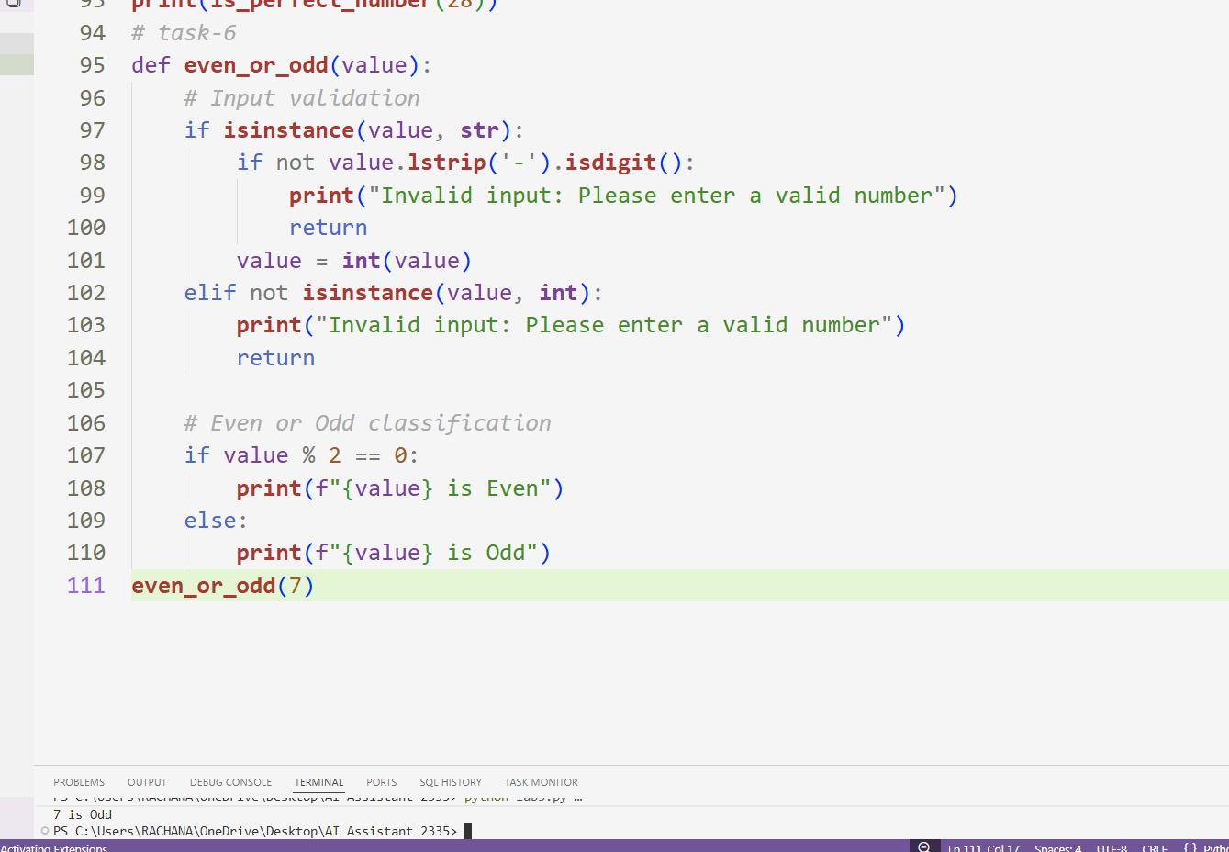
Observation
The program first validates the input to ensure it is either an integer or a numeric string, including negative numbers. Once validated, it converts the input into an integer and checks divisibility by 2 to classify the number as even or odd. This approach prevents runtime errors due to invalid input and ensures accurate classification for both positive and negative integers.

